- \Operation\Ink-jet labeling\Ink-jet labeling A
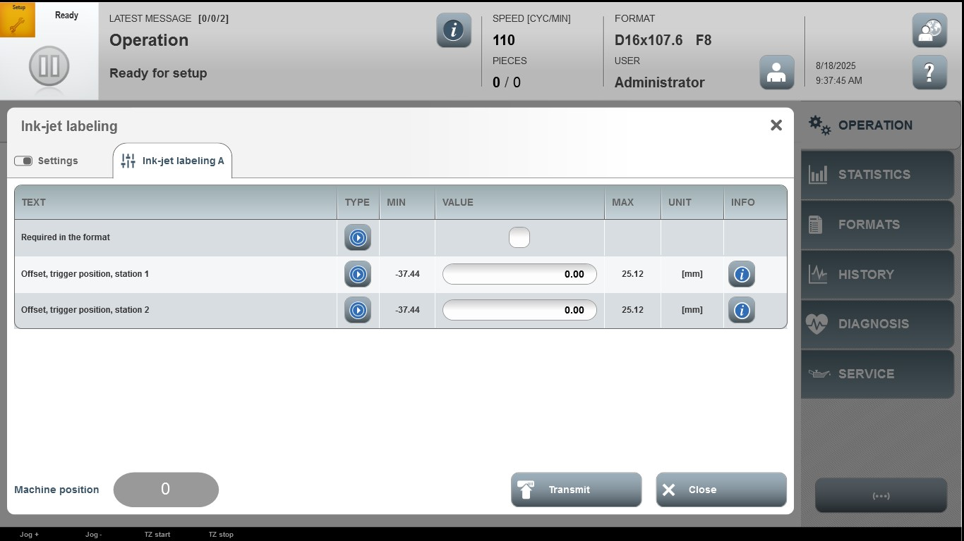

Acceptance criterion | Limits | Pass / Fail: Dev-No. | Date | Initials
Screen matches screenshot | N / A
Offset, target position, station 1 | -37.44…25.12
Offset, target position, station 2 | -37.44…25.12

